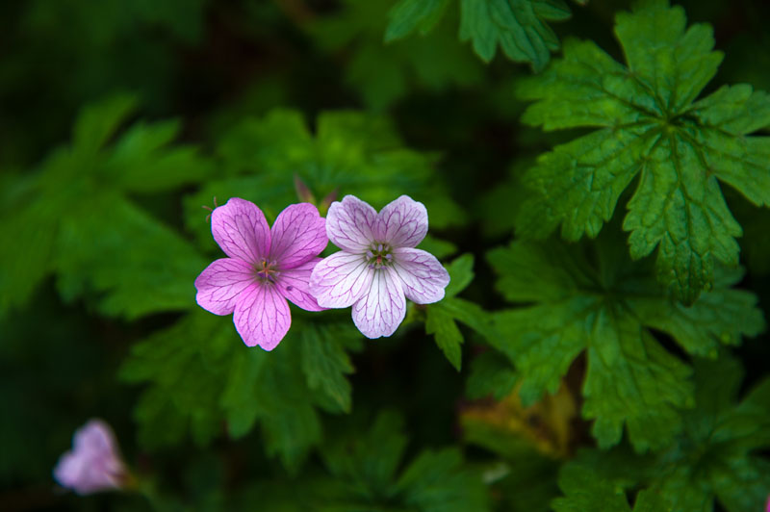
Original picture
Black is transparent, with confetti fill

