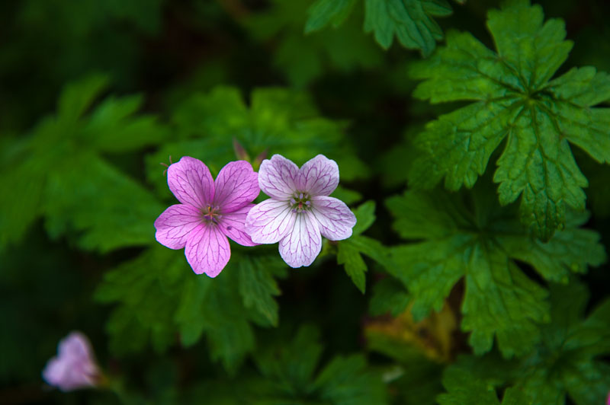
Original picture
Color changed from Color [A=255, R=0, G=0, B=0] to Color [A=255, R=95, G=158, B=160]

